# Introduction

Machinery has been used to aid or even automate productions and operations with higher efficiency, accuracy than human beings ever since the 1st industrial revolution. Machine vision is one of the many other tools that helps bring next level capabilities of observing and analyzing the environment to consumers and operators. These technologies coupled with high speed networking such as 5G and automation, all brings us to the next industrial revolution - Industry 4.0. These tools offer new solutions to conduct industrial activities with minimal waste and high efficiency.

The causes of defects are even more diversified as the sophistication of the photolithography process grows, and the market for defect detection is increasing exponentially. In a typical assembly line, the process of defect identification depends largely on human naked-eye detection. This strategy imposes a higher risk of poor performance, a higher incidence of false identification and a higher sensitivity to subjective variables which are no longer sufficient for modern industrial development needs. Machine Vision inspection technology is widely used in various fields, including wafer inspection, with the development of computer and image processing technology.

An excellent example of a company leading the forefront in machine vision in the world is Vitrox, which is a company dedicated to becoming the world leading company in providing total machine vision solutions. Vitrox started its humble beginnings in 2000, when they began their mission of designing and manufacturing innovative, cutting edge and cost effective automated vision inspection equipment and SoC embedded electronic devices for semiconductor and electronics packaging industries. Vitrox’s core products are its Machine Vision System (MVS), Automated Board Inspection (ABI) and Electronics Communication Systems (ECS).

# Application

## 2D Surface inspection

### Wafer Vision Inspection

The first product is Wafer Vision Inspection handler. The model shown below is Wi8 i G2. The highlight feature of this system is that it provides advanced solutions for different kinds of applications such as measurements, 2D sample surface defect inspections, and it can also handle different types of wafer including raw wafer, hoop ring and framed wafers. It comes with bottom surface inspection and infrared (IR) Inspection Solution. These two new technologies provide new innovative ways to ensure the samples inspected achieve the quality requirements. It allows the user via the wafer frame tape to inspect sawline and crack inspection. With this new technology, at approximately 200μm gross defect, the consumer could carry out backside/bottom inspection for raw wafer under current defect capability. It also conducts backside/bottom inspection on the frame wafer by tape inspection captured at >15μm under current chipping. The IR Inspection solution is intended to inspect internal defects inside the system, such as internal fracture, missing part, delamination, chip-off & etc., which is unachievable by using conventional solutions. In order to check for internal layer flaws, this technology helps users to infiltrate the silicon layer. It dramatically decreases manufacturing downtime and human handling, which increases the precision of the results of the inspection while improving production quality. In the meantime, users can customise their inspection algorithm and update it to satisfy potential inspection needs and optimise output throughput and yield.

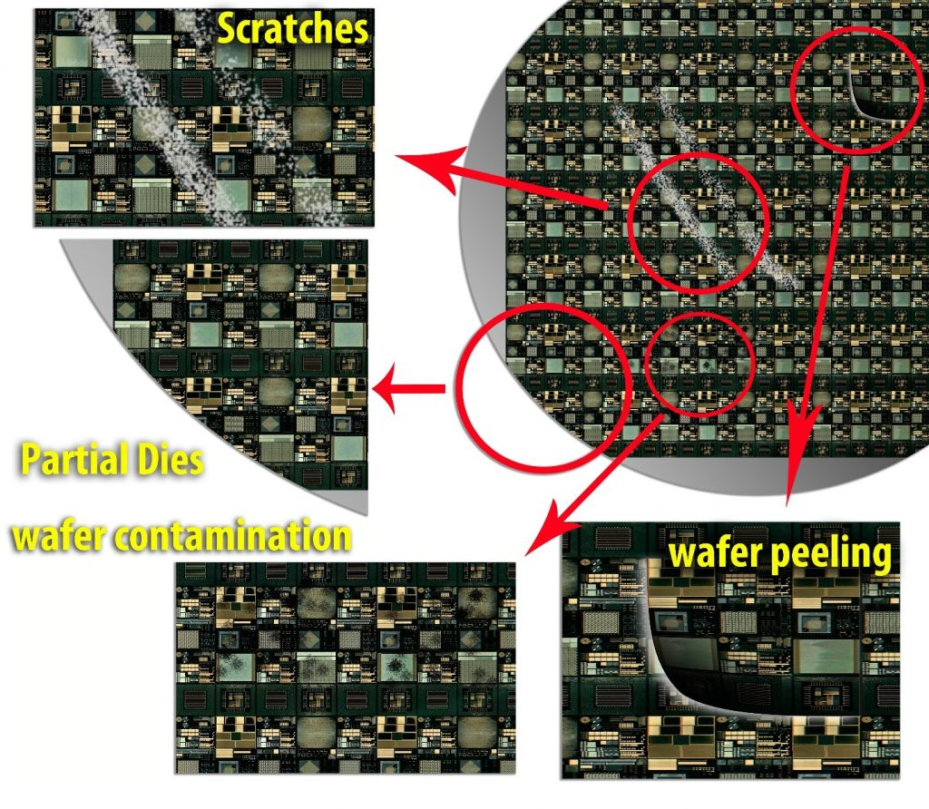

Figure 1 : Examples of wafer defects that have to be inspected

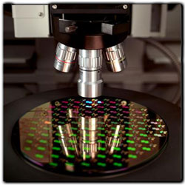

Figure 2: Wafer Vision Inspection

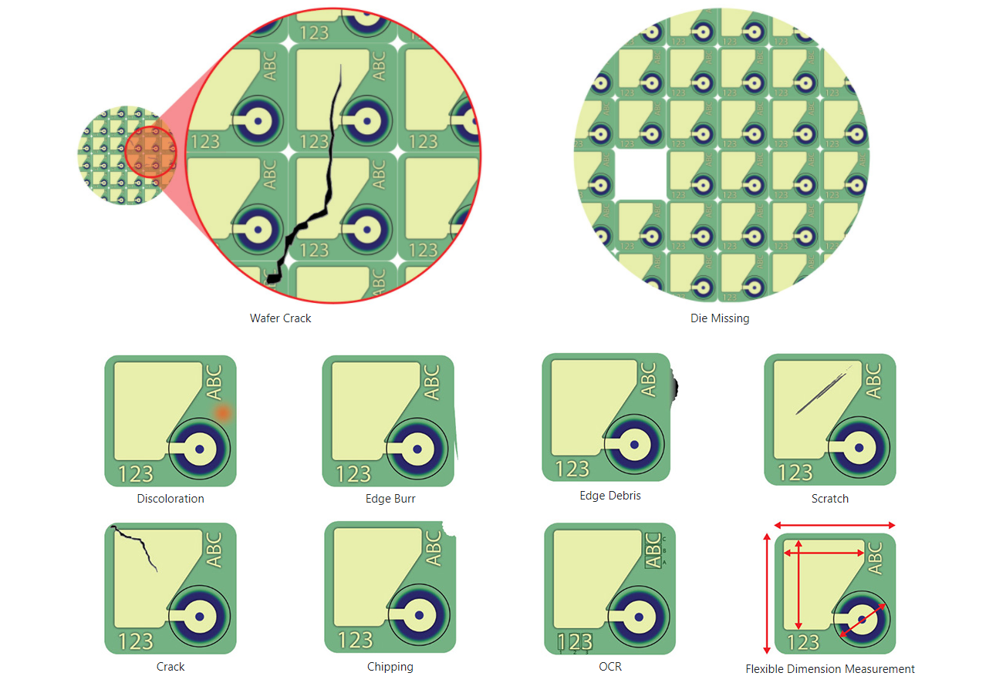

Figure 3 : Wafer defects that are able to be detected by Wi8 i G2

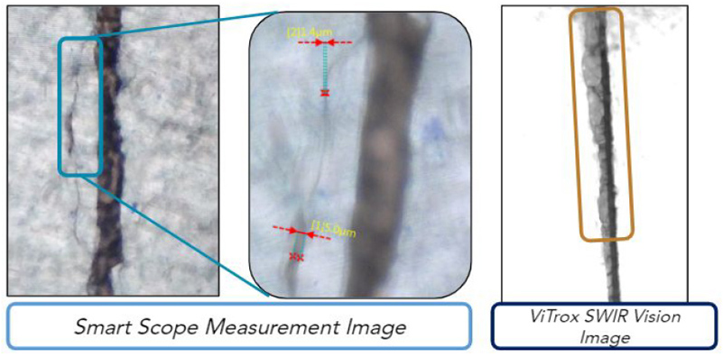

Figure 4: side crack caused by dicing captured by the Wi8i G2

### Post Seal Inspection

Next, Vitrox provides post seal vision handler and tray-based vision handler for vision inspection solutions for Ball Grid Array ( BGA), quad flat package (QFP), quad flat no-leads (QFN), Thin Shrink Small Outline Package (TSSOP), Chip- Scale Package (CSP) Mini Small Outline Package (MSOP) and Small Outline IC Package ( SOP). The post seal vision handler is designed to provide reel-to-reel inspection with many advanced technologies and features. The tray-based vision handler can handle multiple IC packages on a tray. The model currently used is VR20 i. It is able to detect various defects in tape seal, marking on the IC, Package, Lead of IC and bottom carrier tape. The various types of defects the system is able to detect is shown below.

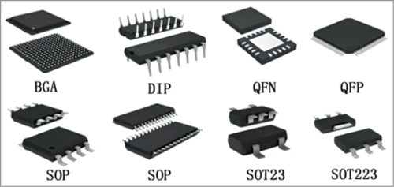

Figure 5: Different types of IC packages

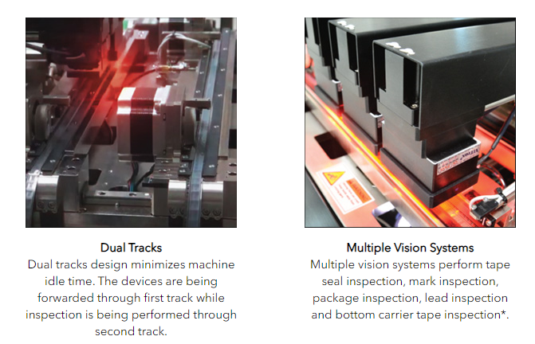

Figure 6: Features Pt.1 of VR20 i

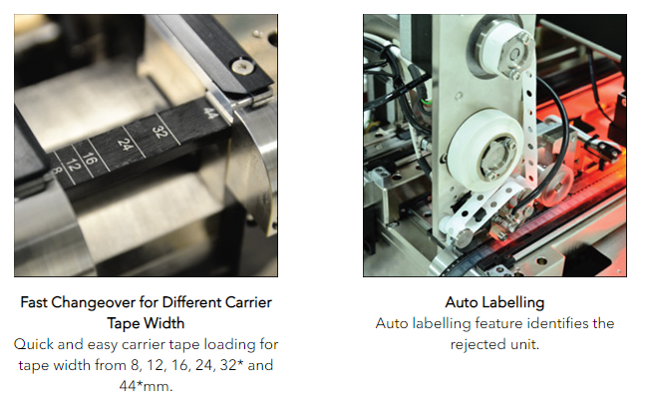

Figure 7: Features Pt.2 of VR20 i

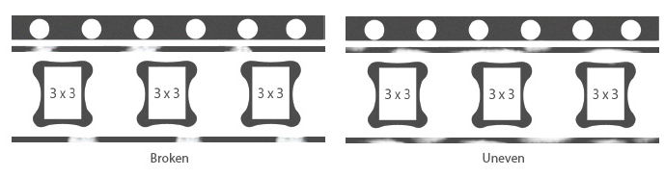

Figure 8: Tape Inspection by VR20 i

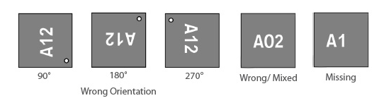

Figure 9: Marking Inspection by VR20 i

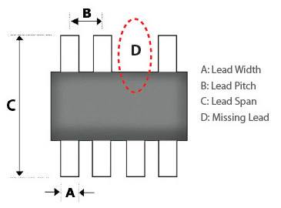

Figure 10: Lead Inspection by VR20 i

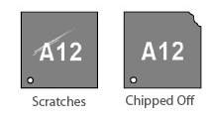

Figure 11: Package Inspection by VR20 i

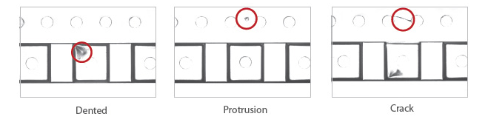

Figure 12: Tape Inspection by VR20 i

### Vision Inspection System for 2D inspection

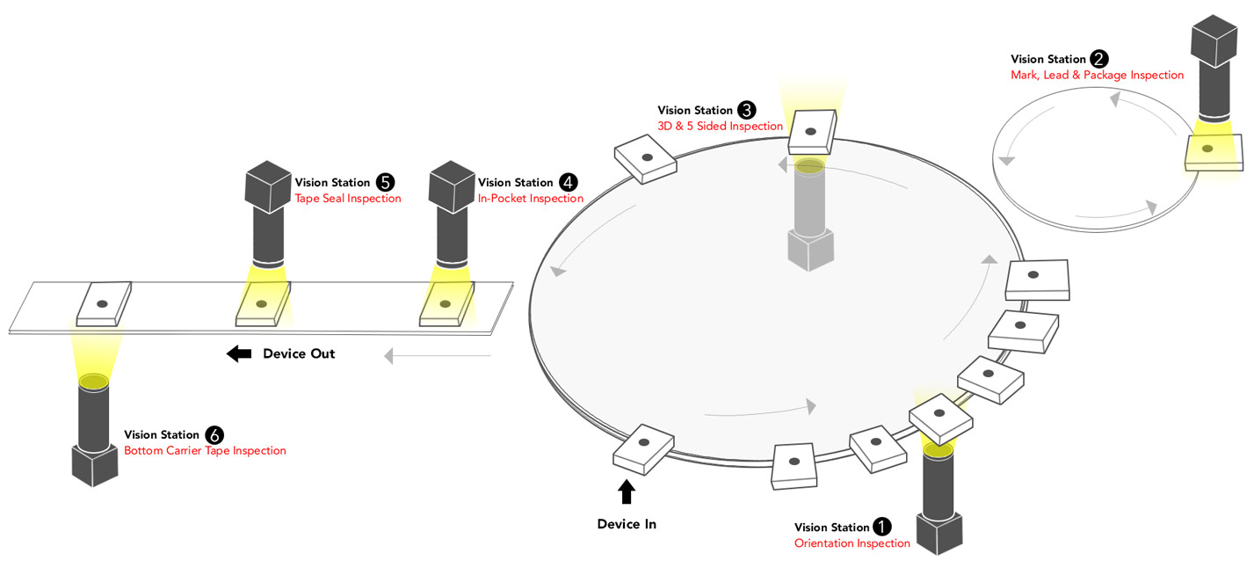

Figure 13: Vision Inspection System for tape/ to-reel models

The packages are being inspected just as shown above. The package is first placed into a plate, and goes through the first station which inspects the orientation of the package. Next, the package reaches the 2nd station, which will have a top view of the package to inspect marks, leads and the package itself. After that, the package reaches the 3rd station where there will be multiple cameras from different angles to capture and inspect 3D (chips with lead) and 5 sides (bottom view and 4 sides for leadless chips) of the package. To capture 4 sides of the package in one image, mirrors are being used. After that, the package is placed into a pocket on the tape, then it goes through the 4th station which inspects mark, lead and package. The 5th station inspects the tape seal from above, while the 6th station inspects the bottom carrier tape for defects. The lights used are usually red and white, depending on the customer’s preference. The cameras used in the stations include telecentric, normal and macro lenses, depending on the application. Telecentric lens is a compound lens that has its exit pupil at infinity, which produces an orthographic view of the package. This lens is used because image magnification is independent of the object’s distance or position in the field of view. One IC package takes about 60 to 70 ms to capture and process the image, so the machine can achieve up to approximately 80,000 devices inspected per minute. The accuracy of the machine is also very high.

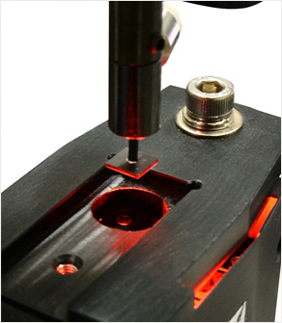

Figure 14: Setup to inspect orientation of package (1st vision station)

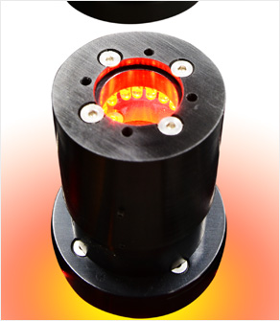

Figure 15: Setup to inspect mark, lead and package (2nd and 4th vision station)

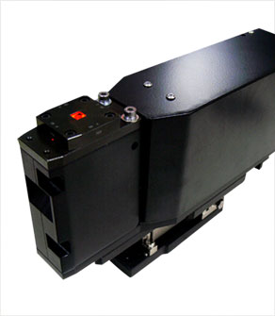

Figure 16: 3D and 5 sides inspection setup ( 3rd vision station)

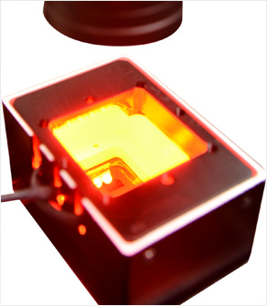

Figure 17: Tape Seal inspection setup (5th vision station)

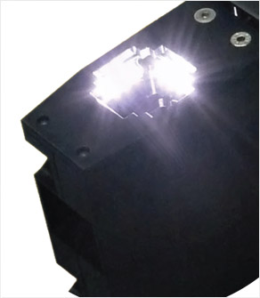

Figure 18: Bottom carrier tape inspection (6th vision station)

## 3D Vision inspection

Advanced 3D Paste Inspection provides solutions for paste inspection on different kinds of PCBs. The model for paste inspection is V310i, with multiple iterations built for different kinds of application with different inspection requirements. It mainly inspects solder paste of various sizes and patterns. This is done by analyzing the area and height of the solder paste, then builds a 3D image of the solder paste. The solder paste will be on boards of blue, black or green colour. The machine vision system is able to detect whether there are any defects of the solder paste such as not enough paste, too much paste or no paste at all. The model features RGB lighting from different angles which helps to filter solder paste, scaling powder and other impurities. Other features include easy programming to set up the device to commercial needs, and high resolution and high frame rate image processing unit(“Vitrox”, n.d.).

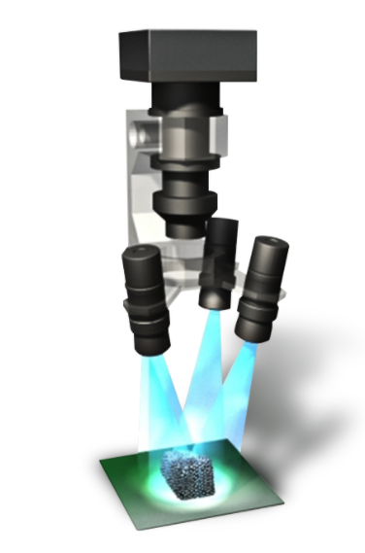

Figure 19: Lighting setup for solder paste inspection

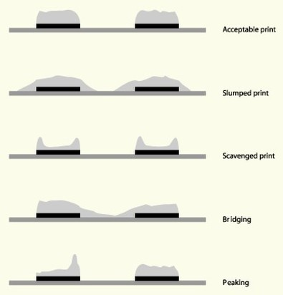

Figure 20: Solder paste defects that can be inspected by API

## 3D X-RAY inspection

AXI Machine Vision System offers a solution to inspect different sizes of PCB assembly at micron level with maximum throughput. The model currently in production is the V810i with different iterations for improved performance or for different use case scenarios. In order to achieve high-quality X-Ray images on highly shaded components or non-uniformly shaded components, the V810i has advanced innovations such as Patented Hybrid Auto Focus Technology, Solder Profile Characteristic and Dynamic Range Optimization (DRO). The speed of these models is around 500 to 1000 images per minute. The images then are processed via Algebraic Reconstruction Technique (ART) which creates a 3D model of the solder paste or ball grid array with good image quality. The model also supports 26 types of industry CAD format, with over 100 robust algorithms threshold and 22 preset joint types for various production environments (“Vitrox”, n.d.).



Figure 21: Example of Image Reconstruction



Figure 22: Example of volume rendering (2D stack to 3D model)

## Conclusion

From above, we can see that with machine vision, Vitrox is able to provide critical and important solutions to other manufacturers to inspect their components whether it is IC package, PCB boards, solder paste and others. Vitrox is continuously improving the technology to increase speed and accuracy of inspection so that customers are able to save time and effort when conducting quality control on their products. This is to show that machine vision plays an important role in maintaining quality of products in the manufacturing and production industry. Machine vision is also useful for many other industries and is a key component in the Industrial Revolution 4,0.

## Reference

1. “Vitrox”. n.d. Back-end Semiconductor. Retrieved from <https://vitrox.com/vision-technology-machine-system/back-end-semiconductor.php>
2. “Vitrox”. n.d. PCB SMT Assembly. Retrieved from https://vitrox.com/vision-technology-machine-system/pcb-smt-assembly.php